A nto ny Da S i Iva

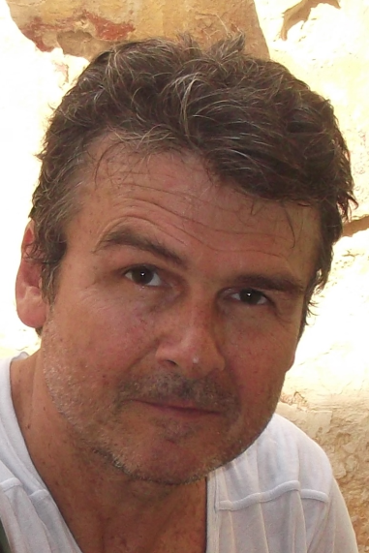Mobile: +356 79869344 Email: a_dasilva01@yahoo.co.uk

Hair Eyes Build Height

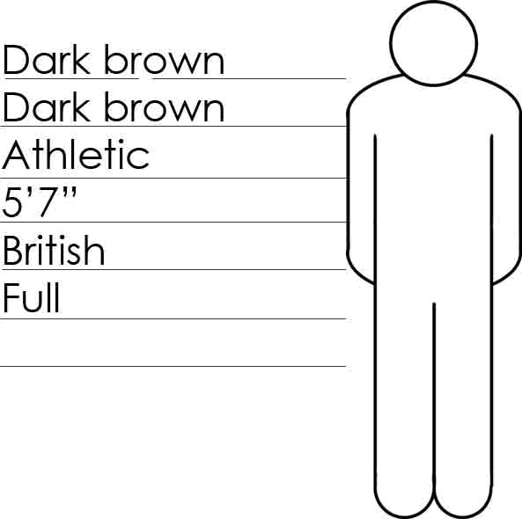

Nationality

Equity

Training

Guildford School of Acting

Sky Film & television training

* Peter Cregeen, Michael Ferguson The Mime centre, London
* Adam Darius

# Current Productions

## Darkwaters- Doctor

## Philip Pullmans The Butterfly Tattoo

— Tommy Sanchez

Theatrical

Fall of the House of Usher — William Wilson Treasure Island — Long John

Shakespeare in Chicago — Dick Viziosso The Price — Arnold P Blinkenstein

The Starry Messenger — Galileo Snow White — The Woodsman Taste of Honey — Peter

The good Old Daze — Giovanni Gianelli On the Verge — Nicky Paradiso

Rimbaud and Verlaine — Gorge lzambard

## Director

## Juan Jose Serrano Olmedo

## Phil Hawkins

Director

Jaume Bello Paolo Abbate Paolo Abbate Jake Lyons

Rachel Mathers

Linda Griffith Arthur Horewood Michael Bennett

Lucille O’Flanagan Adam Darius

## Venue/Company

## U-Film LTD

Dynamic Entertainment DEH Ltd

Venue/Company

2b Theatre — Xip Xap.SL Face 2 Face Theatre 5.L Face 2 Face Theatre 5.L

Walking Forward Theatre Co Quantum Theatre Co Bitesize Theatre Co

lsleworth Theatre Wimbledon Studio Tristian Bates Theatre

Theatre Artaud, The french Institute

Film and Television

Production

Living Room — Music Promo

S.Oliver Commercial

Director

David Barry

Riegler/Deichert

Company

Slinky Productions

Factwory Film Produktions GMBH

VO artist, Telefonica Spots (Braveheart, Mission Impossible, Psycho) Genexies 5.L Madrid VO artist, Magic Moments Book One & Two, Hillside press Athens Greece

VO artist, Avionics Information, The Corporate Image film Company

Voice Over, TVM – Holland & Barrett Ads – LoL Comedy Show

# Skills

Dialects American, European and Hispanic

Languages Fluent Spanish

Vocal Range Baritone (Bottom A—E) Driving Full clean UK driving licence

Sport Martial arts, Nunchaku, Swimming, Yoga & Free Climbing Stage Combat BADC Intermediate